In the Name of God
Islamic Azad University of Isfahan (Khorasgan)

Technical English for Computer Students

By: Dr. Zahra Hosseini & Dr. Narges Habbibi

Feb. 2018

Table of Contents
Chapter 1. Reading: Wearable Devices 4
The Definition of Wearable Devices 4
The Development of Wearable Devices 4
Classification Standards for Wearable Devices 5
Operating System of Wearable Devices 5
New Words 6
Reference 6
Chapter 2. Reading: IoT 7
What Is The Internet of Things (IoT) 7
What It Means For Business? 8
How To Get Started 9
New Words 9
Reference 9
Chapter 3. Writing Essay (Part I) 10
Tips 10
Model Answer 12
Reference 12
Chapter 4. Paper Reading Tips 13
How to read a paper? 13
The Three-Pass Approach 13
The First Pass 13
The Second Pass 14
The Third Pass 14
Exercise 15
Reference 15
Chapter 5. Reading: Deep Learning 16
Deep learning 16
Supervised Learning 17
Deep Learning Architecture 17
New Words 17
Questions 18
Reference 18
Chapter 6. Reading: Health Informatics & Bioinformatics 19
Health Informatics 19
Bioinformatics 19
The Relation Between Health Informatics and Bioinformatics 19
New Words 20
Questions 20
References 20
Chapter 7. Writing Essay (Part II) 21
Exercise 21
Types of Charts 22
A. Bar charts 22
B. Pie Charts 22
C. Line Graphs 23
D. Tables 23
E. Essential Vocabs 25
Reference 27
Chapter 8. Comprehension: The Scientific Method 28

Chapter 1. Reading: Wearable Devices

The Definition of Wearable Devices
A wearable device is a computer that is subsumed into the personal space of a user, controlled by the user, and has both operational and interactional constancy, i.e., is always on and always accessible. Wearable devices have the same computing abilities as mobile phones and tablet computers. In some cases, however, wearable devices are more competent for tasks such as calculation and navigation than handheld devices due to their portability and characteristics to be detailed below.

The Development of Wearable Devices
We can have a clear understanding of the development for wearable devices. Wearable devices have undergone many years of development since the initial ideas and prototypes appeared in the 1960s. During the 1960s to 1970s, wearable devices were in their embryonic period.
People designed wearable devices for special purposes, interests or events. During the period, wearable devices remained in a small-scale field and people rarely understood their roles. In 1966, Edward Thorp, a professor in the Massachusetts Institute of Technology (MIT), invented a pair of shoes that could be used to cheat at roulette. This is the first wearable device in the world. In 1975, the Hamilton Watch Company launched a "calculator" watch which is the world's first wrist calculator. In 1977, the CC Collins designed a wearable device for the blind, which converts images captured from a head-mounted camera into tactile grids located on the blind’s vests.
During the 1980s to 1990s, wearable devices entered the primary stage of development. People began to pay attention to wearable devices. Although wearable technology had a great improvement, wearable devices were still not practical for consumers and not friendly for users. In 1981, Steve Mann designed a head-mounted camera that to some extent can be regarded as the pioneer of Google glasses. In the same year, Steve Mann designed a backpack style computer with text, image and multimedia functions, displaying through the helmet. In 1997, Massachusetts Institute of Technology, Carnegie Mellon University, and Georgia Institute of Technology jointly organized the first International Symposium on Intelligent Wearable Computer (ISWC). Since then, smart wearable computing and smart wearable devices have attracted wide attention in academia and industry.
Since the 21st century, wearable devices have entered an advanced stage of development and aroused widespread concern. They become more complex and are designed according to the needs of users or the market. Many companies independently designed wearable devices and released corresponding software and hardware development platforms. In 2007, James Park and Eric Friedman founded the Fitbit Company that is dedicated to the development of wearable devices such as pedometers and sleep quality detectors. In 2013, Google launched Google glass and caused a sensation in the world. Meanwhile, Apple, Samsung, Sony and other companies have been developing their smart watches.
In the next few years, predictably, wearable devices will enter a period of prosperity. According to Juniper’s research, the number of wearable devices including smart watches and glasses will approach 130 million by 2018. Moreover, the predicted shipments including smart watches and related devices will grow at an annual rate of 78% and reach 112 million by 2018. Therefore, we can believe that wearable devices will gradually enter people's lives and bring convenience to human, and wearable market will attract more participants.

Classification Standards for Wearable Devices
At present, there are two standards for classifying wearable devices. One standard is based on product forms, including head-mounted (such as glass and helmet), body-dressed (such as coat, underwear, and trousers), hand-worn (such as watch, bracelet, and gloves), and foot-worn (such as shoes and socks). Another standard is based on product functions, including healthy living (such as sport wristband and smart bracelet), information consulting (such as smart glass and smart watch). Figure 1 lists a variety of wearable devices.
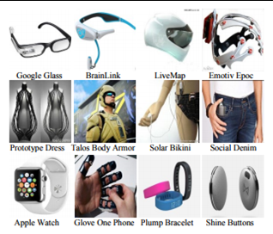
A variety of wearable devices

Operating System of Wearable Devices
Operating system is the interface of hardware and software. Its function is to manage hardware, software and data resources, to control program execution, to improve human computer interaction, to enable users to have a good working environment, and to provide services for users and support for other applications.
The operating system on wearable devices has gone through years of development. As early as in 2000, IBM collaborates with the famous Japanese watch manufacturer Citizen to launch a smart watch named WatchPad with Linux as its operating system. Fossil designed in 2003 a wrist device called Wrist PDA. It equipped with PalmOS operating system and supported screen touch, which were very popular at that time. In addition, Microsoft designed in 2004 the SPOT system for smart watches. In 2013, Samsung released its first smart watch Galaxy Gear using Android as operating system. After that, Samsung launched the second generation of smart watch running Samsung’s independently designed operating system Tizen. In March 2014, based on Android, Google launched a smart watch dedicated operating system called Android Wear, whose operation is implemented through Google Now’s voice commands. Android Wear is expected to build a uniform and standard operating system platform, accelerating the development of wearable devices.
At present, there exist a variety of operating systems in wearable market. But they may not be convenient for users to use. Developers are difficult to choose which operating system for the device. And the application for one operating system is not suitable for another.
Since operating system is essential for wearable devices, we should design wearable operating systems by taking the features of wearable devices into account so that we can achieve the our objectives.

New Words
- Constancy: the quality of being tolerating and unchanging.
- Competent: worthy; having the necessary ability, knowledge, or skill to do something successfully.
- Helmet: is a form of protective gear worn to protect the head from injuries.
- Handheld devices: a piece of computing equipment that can be used in the hand, such as a smartphone or tablet computer.
- Prosperity: the state of being prosperous or successful.
- Tactile grid: a grid that is developed to present sensible information to blind people.
- To cause a sensation: making people passionate and excited.

Reference
He Jiang , Xin Chen, Shuwei Zhang, Xin Zhang, Weiqiang Kong, Tao Zhang. (2015). Software for Wearable Devices: Challenges and Opportunities. Computer Software and Applications Conference (COMPSAC), IEEE. DOI: 10.1109/COMPSAC.2015.269

Chapter 2. Reading: IoT

What Is The Internet of Things (IoT)
The Internet of Things may be a hot topic in the industry but it’s not a new concept. In the early 2000’s, Kevin Ashton was laying the groundwork for what would become the Internet of Things (IoT) at MIT’s AutoID lab. Ashton was one of the pioneers who conceived this notion as he searched for ways to improve its business by linking RFID information to the Internet. The concept was simple but powerful. If all objects in daily life were equipped with identifiers and wireless connectivity, these objects could be communicate with each other and be managed by computers. In a 1999 article for the RFID Journal Ashton wrote: “If we had computers that knew everything there was to know about thing, using data they gathered without any help from us, we would be able to track and count everything, and greatly reduce waste, loss and cost. We would know when things needed replacing, repairing or recalling, and whether they were fresh or past their best. We need to empower computers with their own means of gathering information, so they can see, hear and smell the world for themselves. RFID and sensor technology enable computers to observe, identify and understand the world—without the limitations of human-entered data.” At the time, this vision required major technology improvements. After all, how would we connect everything on the planet? What type of wireless communications could be built into devices? What changes would need to be made to the existing Internet infrastructure to support billions of new devices communicating? What would power these devices? What must be developed to make the solutions cost effective? There were more questions than answers to the IoT concepts in 1999. Today, many of these obstacles have been solved. The size and cost of wireless radios has dropped tremendously. IPv6 allows us to assign a communications address to billions of devices. Electronics companies are building Wi-Fi and cellular wireless connectivity into a wide range of devices. A research estimates over five billion wireless chips shipped in 2013. Mobile data coverage has improved significantly with many networks offering broadband speeds. While not perfect, battery technology has improved and solar recharging has been built into numerous devices. There will be billions of objects, connecting to the network with the next several years. For example, Cisco’s Internet of Things Group (IOTG) predicts there will be over 50 billion connected devices by 2020. IoT describes a system where items in the physical world, and sensors within or attached to these items, are connected to the Internet via wireless and wired Internet connections. These sensors can use various types of local area connections such as RFID, NFC, Wi-Fi, Bluetooth, and Zigbee. Sensors can also have wide area connectivity such as GSM, GPRS, 3G, and LTE. The Internet of Things will:
- Connect both inanimate and living things
- Use sensors for data collection
- Change what types of items communicate over an IP Network
IoT data differ from traditional computing. The data can be small in size and frequent in transmission. The number of devices, or nodes, that are connecting to the network are also greater in IoT than in traditional PC computing. Machine-to-Machine communications, intelligence devices and the network will allow businesses to automate certain basic tasks without depending on central or cloud based applications and services. These attributes present opportunities to collect a wide range of data but also provide challenges in terms of designing the appropriate data networking and security.

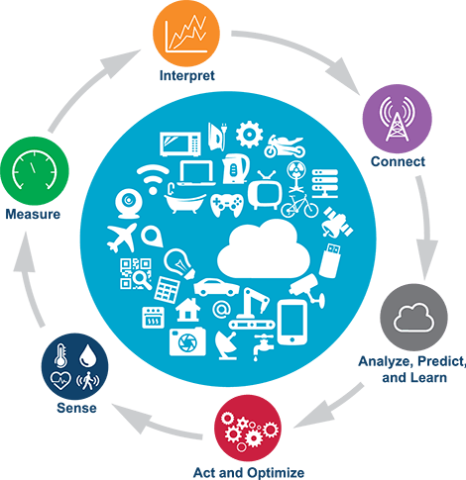
IOT

What It Means For Business?
IoT impacts every business. Mobile and the Internet of Things will change the types of devices that connect into a company’s systems. These newly connected devices will produce new types of data. The Internet of Things will help a business gain efficiencies, improve operations and increase customer satisfaction. IoT will also have a profound impact on people’s lives. It will improve public safety, transportation and healthcare with better information and faster communications of this information. While there are many ways that the Internet of Things could impact society and business, there are at least three major benefits of IOT that will impact every business, which include: communication, control and cost savings.

How To Get Started
IoT can help a business save money, automate processes and gain new insight into the business. To reap the benefits IoT can provide, a business should address at least the following four items:
- Define what you’d like to learn from sensors.
- Build an IOT network and security foundation.
- Collect as much data as possible.
- Review the size and scale of IoT providers.

New Words
- Groundwork: preliminary or basic work
- Infrastructure: the basic physical and organizational structures and facilities
- Notion: an impulse or desire
- Recalling: bring (a fact, event, or situation) back into one's mind; remember
- Reap: collect
- Solar: of, relating to, or determined by the sun.
- Profound: deep

Reference
Lopez Research LLC. 2013. An Introduction to the Internet of Things.

Chapter 3. Writing Essay (Part I)

We are becoming increasingly dependent on computers. They are used in business, hospitals, crime detection and even to fly planes. What things will they be used in the future? Is this dependence on computers a good thing or should we be more suspicious of their benefits?

Tips
- Find the main questions: In the following example,
- What things computers will be used in the future?
- Is this dependence on computers a good thing or should we be more suspicious of their benefits?
- Discuss arguments of each question, for instance:
- Arguments: Why the dependency on computers is a good thing.
- Arguments: Why we should be more suspicious of the benefits computers offer?
- Dedicate each paragraph to an argument.
- Employ linking words to make reasonable statements (see Table 1).

Linking words
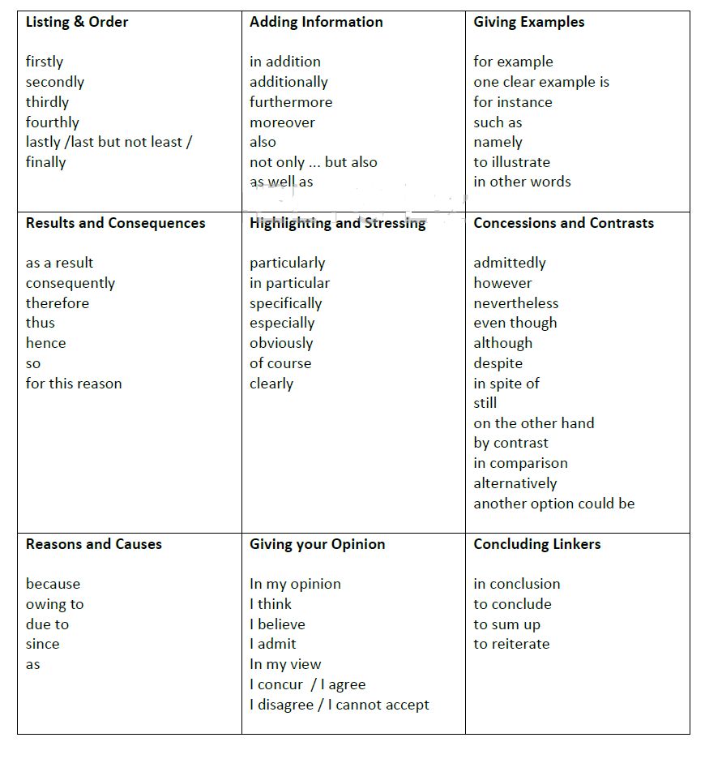

Model Answer
Today, the computer has become an indispensable tool in our day-to-day activities. In fact, we find it very difficult to get through a working day without it. In this essay, we will discuss the usage of computers in the foreseeable future. Also, we will analyze how this dependency will have negative impacts on the society.
To begin with, computers can be used in performing daily chores at the house. For instance, cleaning of the home can be done with the minimum effort and time with the advent of robot maids. In addition, teachers can use computers for teaching their students by staying at their own place. In other words, tutors can arrange multiple classes in different cities at the same time by the help of this tool. Thus, it is obvious that the computer can be used in household work as well as for teaching purpose in the coming future.
However, inordinate usage of this tool has many disadvantages. First of all, human beings will be replaced by this machine leading to the increase in the unemployment which is intrinsically tied to the rate of the crime within the nation. Furthermore, the absence of physical presence of teachers in the classroom can raise the problems of discipline within the students. In other words, social development of these pupils will be harmed and thereby, will cause a hindrance in the nation's social growth.
From above, it can be seen that computers will be used for various activities at home as well as at educational institutions in the future. But, excessive utilization of this machine can boost the issues related to job causing rise in the crime and afflict the young people's development. It is thus hoped that people will be made aware of the harmfulness of relying too much on computers.

Reference
https://www.testbig.com

Chapter 4. Paper Reading Tips

How to read a paper?
Much of a scientist’s work involves reading research papers, whether it’s to stay up to date in their field, advance their scientific understanding, review manuscripts, or gather information for a project proposal or grant application. Because scientific articles are different from other texts, like novels or newspaper stories, they should be read differently.
Research papers follow the well-known IMRD format — an abstract followed by the Introduction, Methods, Results and Discussion. They have multiple cross references and tables as well as supplementary material, such as data sets, lab protocols and gene sequences. All those characteristics can make them dense and complex. Being able to effectively understanding them is a matter of practice.
Reading a scientific paper should not be done in a linear way (from beginning to end); instead, it should be done strategically and with a critical mindset, questioning your understanding and the findings. Sometimes you will have to go backwards and forwards, take notes and have multiples tabs opened in your browser.

The Three-Pass Approach
The key idea is that you should read the paper in up to three passes, instead of starting at the beginning and going your way to the end. Each pass accomplishes specific goals and builds upon the previous pass: The first pass gives you a general idea about the paper (Skim). The second pass lets you grasp the paper’s content, but not its details. The third pass helps you understand the paper in depth. (Re-read, interpret and summarize)

The First Pass
The first pass is a quick scan to get a bird’s-eye view of the paper. You can also decide whether you need to do any more passes. This pass should take about five to ten minutes and consists of the following steps:
- Carefully read the title, abstract, and introduction.
- Read the section and sub-section headings, but ignore everything else.
- Glance at the mathematical content (if any) to determine the underlying theoretical foundations.
- Read the conclusions.
- Glance over the references, mentally ticking off the ones you’ve already read.
At the end of the first pass, you should be able to answer:
- Category: What type of paper is this? A measurement paper? An analysis of an existing system? A description of a research prototype?
- Context: Which other papers is it related to? Which theoretical bases were used to analyze the problem?
- Correctness: Do the assumptions appear to be valid?
- Contributions: What are the paper’s main contributions?
- Clarity: Is the paper well written?

Using this information, you may choose not to read further (and not print it out, thus saving trees).

The Second Pass
In the second pass, read the paper with greater care, but ignore details such as proofs. It helps to jot down the key points, or to make comments in the margins, as you read.
The second pass should take up to an hour for an experienced reader. After this pass, you should be able to grasp the content of the paper. You should be able to summarize the main subject of the paper. This level of detail is appropriate for a paper in which you are interested, but does not lie in your research specialty.
Sometimes you won’t understand a paper even at the end of the second pass. This may be because the subject matter is new to you, with unfamiliar terminology and acronyms (abbreviations). Or the authors may use a proof or experimental technique that you don’t understand, so that the bulk of the paper is incomprehensible. The paper may be even poorly written or it could just be that it’s late at night and you’re tired. You can now choose to:
- Set the paper aside, hoping you don’t need to understand the material to be successful in your career.
- Return to the paper later, perhaps after reading background material.
- Persevere and go on to the third pass.

The Third Pass
This pass requires great attention to detail. You should identify and challenge every assumption in every statement. Moreover, you should think about how you yourself would present a particular idea.
During this pass, you should also think of ideas for future work. This pass can take many hours for beginners and more than an hour or two even for an experienced reader. At the end of this pass, you should be able to reconstruct the entire structure of the paper from memory, as well as be able to identify its strong and weak points.
In particular, you should be able to pinpoint implicit assumptions, missing citations to relevant work, and potential issues with experimental or analytical techniques.

Exercise
Bring this paper for the next week to work on: “Application of Genetic Algorithms to Data Mining by Robert E. Marmelstein”

Reference
S. Keshav, David R. Cheriton School of Computer Science, University of Waterloo.

Chapter 5. Reading: Deep Learning

Deep learning
Deep Learning is a new area of Machine Learning research, which has been introduced with the objective of moving Machine Learning closer to one of its original goals: Artificial Intelligence. Deep Learning is about learning multiple levels of representation and abstraction that help to make sense of data such as images, sound, and text.
These methods have dramatically improved the state-of-the-art in speech recognition, visual object recognition, object detection and many other domains such as drug discovery and genomics. Deep learning discovers intricate structure in large data sets by using the back-propagation algorithm to indicate how a machine should change its internal parameters that are used to compute the representation in each layer from the representation in the previous layer. Deep convolutional nets have brought about breakthroughs in processing images, video, speech and audio, whereas recurrent nets have shone light on sequential data such as text and speech.
Conventional machine-learning techniques were limited in their ability to process natural data in their raw form. For decades, constructing a pattern-recognition or machine-learning system required careful engineering and considerable domain expertise to design a feature extractor that transformed the raw data (such as the pixel values of an image) into a suitable internal representation or feature vector from which the learning subsystem, often a classifier, could detect or classify patterns in the input.
Representation learning is a set of methods that allows a machine to be fed with raw data and to automatically discover the representations needed for detection or classification. Deep-learning methods are representation-learning methods with multiple levels of representation, obtained by composing simple but non-linear modules (see Figure 1) that each transform the representation at one level (starting with the raw input) into a representation at a higher, slightly more abstract level.

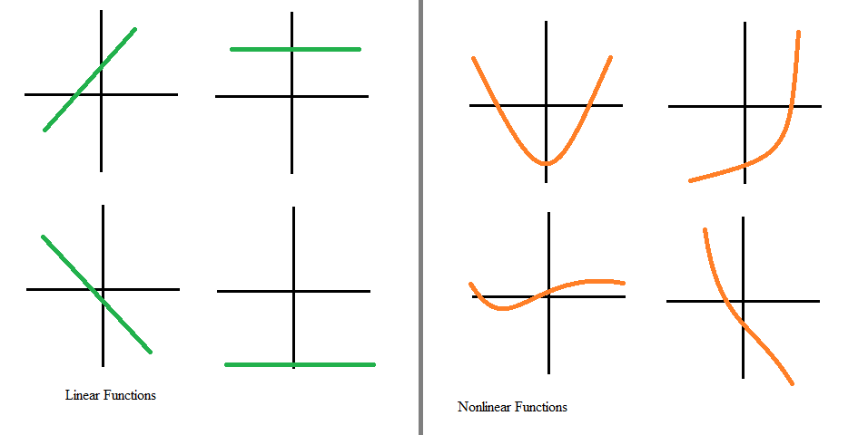
Linear Vs. non-linear functions

Supervised Learning
The most common form of machine learning, deep or not, is supervised learning. Imagine that we want to build a system that can classify images as containing, say, a house, a car, a person or a pet. We first collect a large data set of images of houses, cars, people and pets, each labelled with its category. During training, the machine is shown an image and produces an output in the form of a vector of scores, one for each category (see Figure 2.) We want the desired category to have the highest score of all categories, but this is unlikely to happen before training. We compute an objective function that measures the error (or distance) between the output scores and the desired pattern of scores. The machine then modifies its internal adjustable parameters to reduce this error. These adjustable parameters, often called weights, are real numbers that define the input–output function of the machine. In a typical deep-learning system, there may be hundreds of millions of these adjustable weights, and hundreds of millions of labelled examples with which to train the machine.
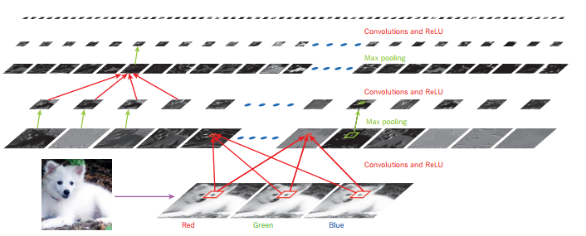
Figure 2. Inside a convolutional network

Deep Learning Architecture
A deep-learning architecture is a multilayer stack of simple modules, all (or most) of which are subject to learning, and many of which compute non-linear input–output mappings. Each module in the stack transforms its input to increase both the selectivity and the invariance of the representation. With multiple non-linear layers, say a depth of 5 to 20, a system can implement extremely complex functions of its inputs that are simultaneously sensitive to minute details — distinguishing and insensitive to large irrelevant variations such as the background, pose, lighting and surrounding objects.

New Words
- Abstraction: the quality of dealing with ideas rather than events.
- Breakthroughs: a sudden, dramatic, and important discovery or development especially in technology.
- Conventional: based on or in accordance with what is generally done or believed.
- Domain expertise: having authority in a particular area or topic.
- Intricate: complex.
- Invariance: the property of remaining unchanged regardless of changes in the conditions of measurement.
- Machine-learning: is a field of computer science that gives computers the ability to learn without being explicitly programmed.
- Minute: Extremely small.
- Pattern-recognition: is a branch of machine learning that emphasizes the recognition of data patterns or data regularities in a given scenario.
- Selectivity: the quality of carefully choosing someone or something as the best or most suitable
- Simultaneously: at the same time
- State-of-the-art: the most recent stage in the development of a product, incorporating the newest ideas and features.

Questions
Answer the following questions:
- Which section contains information about drawbacks of old machine learning algorithms?
- What is an objective function?
- Determine whether the following statements are “true”, “false” or “not given”?
  - “ Deep learning algorithms are susceptible to backside objects”
  - “representational learning algorithms are more powerful with non-linear functions”

Reference
Sridhar, G. 2018. Artificial Intelligence (Way to Future)

Chapter 6. Reading: Health Informatics & Bioinformatics

Health Informatics
Health informatics (also called health care informatics, healthcare informatics, medical informatics, nursing informatics, clinical informatics, or biomedical informatics) is informatics in health care, essentially the management and use of patient healthcare information. It is a multidisciplinary field that uses health information technology (HIT) to improve health care via any combination of higher quality, higher efficiency, and new opportunities. The disciplines involved include information science, computer science, social science, behavioral science, management science, and others. It deals with the resources, devices, and methods required to optimize the acquisition, storage, retrieval, and use of information in health and biomedicine.
It is applied to the areas of nursing, clinical medicine, dentistry, pharmacy, public health, biomedical research, and alternative medicine, all of which are designed to improve the overall of effectiveness of patient care delivery by ensuring that the data generated is of a high quality.

Bioinformatics
The bioinformatics is an interdisciplinary field that develops methods and software tools for understanding biological data. As an interdisciplinary field of science, bioinformatics combines computer science, biology, mathematics, and engineering to analyze and interpret biological data. Bioinformatics has been used for in silico analyses of biological queries using mathematical and statistical techniques.

The Relation Between Health Informatics and Bioinformatics
With the completion of the human genome and the recent advent of high throughput sequencing and genome-wide association studies of single nucleotide polymorphisms, the fields of molecular bioinformatics, biostatistics, statistical genetics and clinical informatics are converging into the emerging field of translational bioinformatics.
The relationship between bioinformatics and health informatics, while conceptually related under the umbrella of biomedical informatics, has not always been very clear. The TBI community is specifically motivated with the development of approaches to identify linkages between fundamental biological and clinical information. Along with complementary areas of emphasis, such as those focused on developing systems and approaches within clinical research contexts, insights from TBI may enable a new paradigm for the study and treatment of disease.
Today, TBI field is categorized into four major areas that are briefly described below:
- Clinical big data: Clinical big data is a collection of electronic health records that are used for innovations.
- Genomics in clinical care: Genomic data are used to identify the genes involvement in unknown or rare conditions/syndromes. Currently, the most vigorous area of using genomics is oncology. The identification of genomic sequencing of cancer may define reasons of drug(s) sensitivity and resistance during oncological treatment processes.
- Omics for drugs discovery and repurposing: The drug repurposing is an appealing idea that allows the pharmaceutical companies to sell an already approved drug to treat a different condition/disease that the drug was not initially approved for by the FDA. The observation of “molecular signatures in disease and compare those to signatures observed in cells” points to the possibility of a drug ability to cure and/or relieve symptoms of a disease.
- Personalized genomic testing: In the USA, several companies offer direct-to-consumer (DTC) genetic testing. The company that performs the majority of testing is called 23andMe.

New Words
- Acquisition: an object bought or obtained.
- Appealing: attractive or interesting.
- Converge: (of several people or things) come together from different directions so as eventually to meet.
- Efficient: (especially of a system or machine) achieving maximum productivity with minimum wasted effort or expense.
- Insight: the capacity to gain an accurate and deep intuitive understanding of a person or thing.
- In silico: is an expression used to mean "performed on computer or via computer simulation”.
- Interdisciplinary: of or relating to more than one branch of knowledge.
- Interpret: explain the meaning of (information, words, or actions).
- Linkage: the action of linking or the state of being linked.
- Multidisciplinary: combining or involving several academic disciplines or professional specializations in an approach to a topic or problem.
- Optimize: make the best or most effective use of (a situation, opportunity, or resource).
- Repurposing: adapt for use in a different purpose.
- Resistance: the refusal to accept or comply with something; the attempt to prevent something by action or argument.
- Retrieval: the process of getting something back from somewhere.
- Treatment: the manner in which someone behaves toward or deals with someone or something.
- Vigorous: strong, healthy, and full of energy.

Questions
Answer the following questions:
- What is the main purpose of health infomratics?
- What is the main purpose of bioinformatics?
- Mention the four categories of TBI.

References
https://en.wikipedia.org/wiki/Health_informatics
https://en.wikipedia.org/wiki/Bioinformatics

Chapter 7. Writing Essay (Part II)

Writing Essay: Charts, Flowchart and Table Writing
- Start by explaining exactly what chart shows. Avoid copying words in the question, use other words with the same or similar meanings.
- Mention the survey question the participants.
- Explain what the different sections of the chart refer to.
- Describe the key finding shown in the chart.
- Use correct synonyms in your writing.
- Use a range of vocabulary.
- Do not repeat words and phrases from the exam question unless there is no alternative.
- Use less common vocabulary.
- Do not use the same word more than once/twice.
- Use precise and accurate words in a sentence.

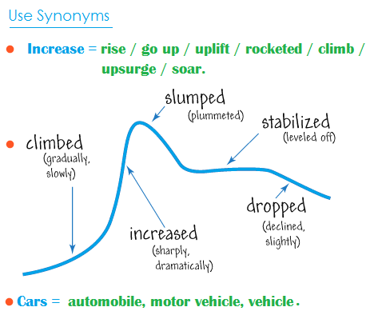

Exercise
- Find synonyms of decrease

Types of Charts

A. Bar charts
A bar chart consists of rectangular bars arranged horizontally or vertically from the x or y axis.

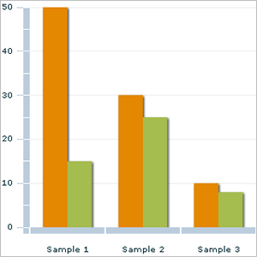

The length of a bar shows the values it represents. The values are listed on one axis and each bar shows what is being measured on the other axis. Bar charts are useful for comparing data. In studying a bar chart, you may want to look for the following information:
- Which is the tallest bar?
- Which is the shortest bar?
- Have the bars changed over time? How?
- How do the bars compare to each other?

B. Pie Charts
A pie charts is a circular chart divided into sectors or pie slices. It presents information in segments of a circle or pie, which together add up to 100%. Here's an example:
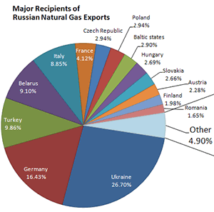

Ask yourself:
- Which is the largest segment?
- Which is the smallest segment?
- How do the segments compare with each other?

C. Line Graphs
A line graph plots the changes in data over time:

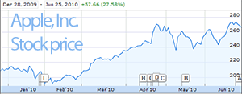

Ask yourself:
- What is the highest level / point?
- What is the lowest level / point?
- Is there a point till when the trend was increasing or decreasing?
- When did the trend change?

D. Tables
A table presents information in different categories, making it easy to compare. The sample table below shows the percentage of students who came to college on foot, by car, bicycle or public transportation, at Williams College in the year 2005-2006.

Method of student travel to college by percentage
Walking | 12
Bicycle | 20
Car | 25
Public Transport | 43

Look out for the following:
- What is the highest figure?
- What is the lowest figure?
- What is second highest, etc.?

E. Essential Vocabs

Starting | Presentation Type | Verb | Description
The given / the supplied / the presented / the shown / the provided/ the | diagram / table / figure / illustration / graph / chart / flow chart / picture/ presentation/ pie chart / bar graph/ column graph / line graph / table data/ data / information / pictorial/ process diagram/ map/ pie chart and table/ bar graph and pie chart ... | shows / represents / depicts / enumerates / illustrates / presents/ gives / provides / delineates/ outlines/ describes / delineates/ expresses/ outlines/ denotes/ compares/ shows contrast / indicates / figures / gives data on / gives information on/ presents information about/ shows data about/ demonstrates/ outlines/ summarizes... | The comparison of…  the differences…  the changes...  the number of…  information on…  data on…  the proportion of…  the amount of…  information on...  data about...  comparative data...  the trend of...  the percentages of...

Examples
- The provided diagram shows data on employment categories in energy producing sectors in Europe starting from 1925 and till 1985.
- The given pie charts represent the proportion of male and female employee in 6 broad categories, divided into manual and non-manual occupations in Freedonia.

Example:
- Describe the following flowchart.
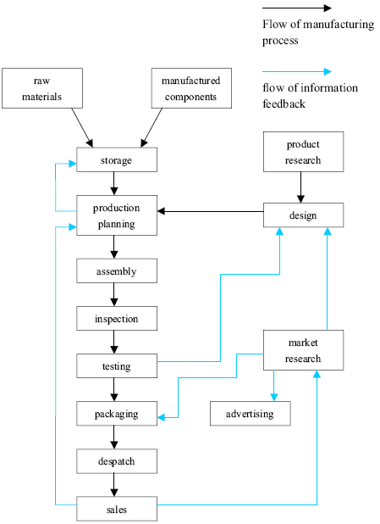
Model Answer
The given diagram shows the steps of the consumer products manufacturing process, as is clearly shown in the diagram that goods manufacturing is a complex process from collection of raw materials to the end product.
As the process clearly shows the first stage of product development is collection and storage of raw materials and manufacturing components. The second stage involves designing of the products and production planning and it’s a lengthy process which includes supervision and monitoring designing progress frequently, and before market surveys, it is necessary to test the product to be aware the quality of the product. If the product is quality wise good then the next stage is packing of the products and make advertising for sale. In this production and manufacturing process, there are mainly two types of processes- the flow of manufacturing process and the flow of information feedback.
In summary, it is value chain development process that starts from collection of raw materials to the end or final product for sale, in each stage of this manufacturing process value is added to products.

Reference
https://learnenglishteens.britishcouncil.org

Chapter 8. Comprehension: The Scientific Method

Read the following passage and answer the questions, you may not use a dictionary.

A: ‘Hypotheses,’ said Medawar in 1964, are imaginative and inspirational in character’; they are ‘adventures of the mind’. He was arguing in favor of the position taken by Karl Popper in The Logic of Scientific Discovery (1972, 3rd edition) that the nature of scientific method is hypothetico-deductive and not, as is generally believed, inductive.

B: It is essential that you, as an intending researcher, understand the difference between these two interpretations of the research process so that you do not become discouraged or begin to suffer from a feeling of ‘cheating’ or not going about it the right way.

C: The myth of scientific method is that it is inductive: that the formulation of scientific theory starts with the basic, raw evidence of the senses - simple, unbiased, unprejudiced observation. Out of these sensory data - commonly referred to as ‘facts’ — generalizations will form. The myth is that from a disorderly array of factual information an orderly, relevant theory will somehow emerge. However, the starting point of induction is an impossible one.

D: There is no such thing as an unbiased observation. Every act of observation we make is a function of what we have seen or otherwise experienced in the past. All scientific work of an experimental or exploratory nature starts with some expectation about the outcome. This expectation is a hypothesis. Hypotheses provide the initiative and incentive for the inquiry and influence the method. It is in the light of an expectation that some observations are held to be relevant and some irrelevant, that one methodology is chosen and others discarded, that some experiments are conducted and others are not. Where is, your naive, pure and objective researcher now?

E: Hypotheses arise by guesswork, or by inspiration, but having been formulated they can and must be tested rigorously, using the appropriate methodology. If the predictions, you make as a result of deducing certain consequences from your hypothesis are not shown to be correct then you discard or modify your hypothesis. If the predictions turn out to be correct then your hypothesis has been supported and may be retained until such time as some further test shows it not to be correct. Once you have arrived at your hypothesis, which is a product of your imagination, you then proceed to a strictly logical and rigorous process, based upon deductive argument — hence the term ‘hypothetico-deductive’.

F: So don’t worry if you have some idea of what your results will tell you before you even begin to collect data; there are no scientists in existence who really wait until they have all the evidence in front of them before they try to work out what it might possibly mean. The closest we ever get to this situation is when something happens by accident; but even then the researcher has to formulate a hypothesis to be tested before being sure that, for example, a mould might prove to be a successful antidote to bacterial infection.

G: The myth of scientific method is not only that it is inductive (which we have seen is incorrect) but also that the hypothetico-deductive method proceeds in a step-by-step, inevitable fashion. The hypothetico-deductive method describes the logical approach to much research work, but it does not describe the psychological behavior that brings it about. This is much more holistic — involving guesses, reworkings, corrections, blind alleys and above all inspiration, in the deductive as well as the hypothetic component -than is immediately apparent from reading the final thesis or published papers. These have been, quite properly, organized into a more serial, logical order so that the worth of the output may be evaluated independently of the behavioral processes by which it was obtained. It is the difference, for example between the academic papers with which Crick and Watson demonstrated the structure of the DNA molecule and the fascinating book The Double Helix in which Watson (1968) described how they did it. From this point of view, ‘scientific method’ may more usefully be thought of as a way of writing up research rather than as a way of carrying it out.

The reading Passage has seven paragraphs A-G. Choose the most suitable headings for paragraphs C-G from the list of headings below. Write the appropriate numbers i-x in boxes below.
Example Paragraph A Answer: ix
List of Headings
i | The Crick and Watson approach to research
ii | Antidotes to bacterial infection
iii | The testing of hypotheses
iv | Explaining the inductive method
v | Anticipating results before data is collected
vi | How research is done and how it is reported
vii | The role of hypotheses in scientific research
viii | Deducing the consequences of hypotheses
ix | Karl Popper’s claim that the scientific method is hypothetico-deductive
x | The unbiased researcher

- Paragraph C
- Paragraph D
- Paragraph E
- Paragraph F
- Paragraph G
- In which two paragraphs in the reading passage * does the writer give advice directly to the reader?
- Which of the following statements best describes the writer’s main purpose in Reading Passage?
    - to advise students not to cheat while carrying out research.
    - to encourage students to work by guesswork and inspiration.
    - to explain to students, the logic which the scientific research paper follows.
    - to help students by explaining different conceptions of the research process.

